**Lab2**

Creating Orgs and Peers

In our previous lab we have installed Fabric-samples.

**STEP1: Creating Organisation and Artefacts**

1. Navigate to fabric-samples/first-network in file explorer.

We will add Orgs to our new Network. (Let us create 3 Orgs. In our case we will create the following **apollo1.silverlake.co.in, manipal2.silverlake.co.in, fortis3.silverlake.co.in)**

Edit **crypto-config.yaml** file to add the three organisations

Open yaml File

Edit the orderer definitions given as below

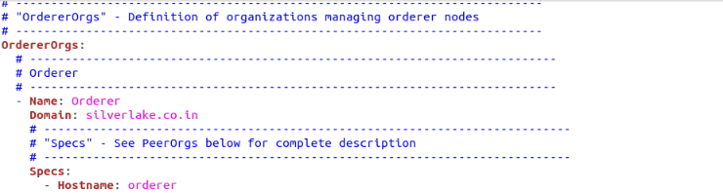

Edit the peer definitions given as below

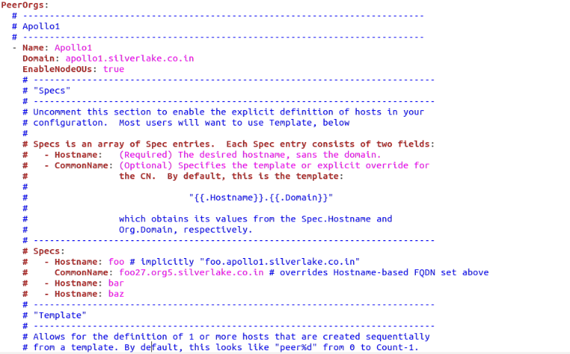

Default crypto-config.yaml file consists of 2 orgs.

Add Org3 definitions as per the below image:

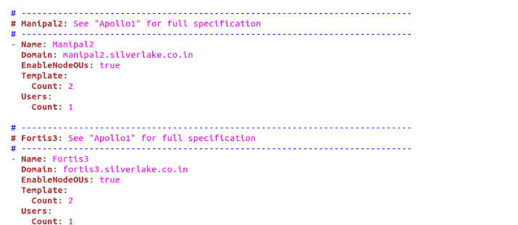

1. Traverse to the fabric-samples/first-network and execute the below command

**../bin/cryptogen generate --config=./crypto-config.yaml**

**The output should be**

apollo1.silverlake.co.in

manipal2.silverlake.co.in

fortis3.silverlake.co.in

**🡪 3 Organisations have got created.**

* **crypto-config folder has been created. Explore the folder to view orderer organization and peer organization.**
* **Navigate peer organization to view the 3 organisations created as per the configuration.**

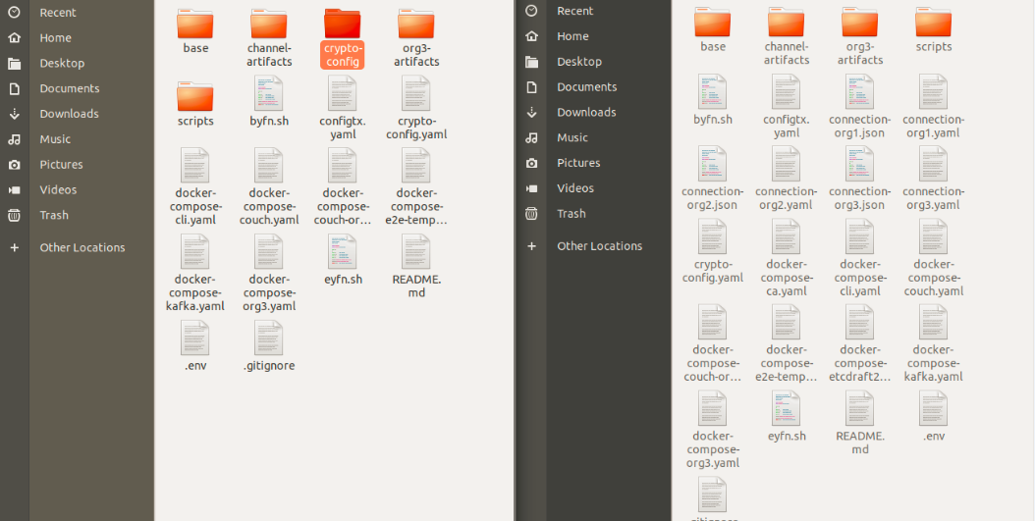

1. Create Artefacts

- creating artefacts for channel

- creating consortium

- creating genesis block

Now edit the configtx.yaml file in first-network folder.

Open the word file to view the changes that need to be incorporated in configtx.yaml file.

******

(Open the artifacts file to get the configtx.yaml file)

******

Run the below command to create the following

🡪to form a consortium of 3orgs

🡪to create a genesis block

🡪to create artefact for channel

**../bin/configtxgen -profile TwoOrgsOrdererGenesis -channelID byfn-sys-channel -outputBlock ./channel-artifacts/genesis.block**

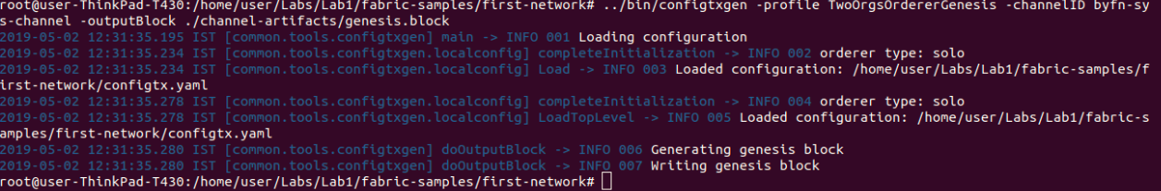

**Navigate to Channel-artifacts and observe that genesis-block has been created.**

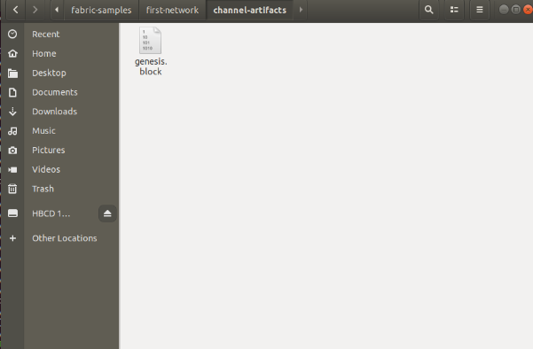

**STEP2: Creating artefacts for channel and anchor peers**

1. Now let’s create a channel and join the Peers from the Orgs of Consortium:

**export CHANNEL_NAME=mychannel**

1. Execute the below command to create a channel

**../bin/configtxgen -profile TwoOrgsChannel -outputCreateChannelTx ./channel-artifacts/channel.tx -channelID $CHANNEL_NAME**

1. Create artefacts for anchor peer

**../bin/configtxgen -profile TwoOrgsChannel -outputAnchorPeersUpdate ./channel-artifacts/Apollo1MSPanchors.tx -channelID $CHANNEL_NAME -asOrg Apollo1MSP**

**../bin/configtxgen -profile TwoOrgsChannel -outputAnchorPeersUpdate ./channel-artifacts/Manipal2MSPanchors.tx -channelID $CHANNEL_NAME -asOrg Manipal2MSP**

**../bin/configtxgen -profile TwoOrgsChannel -outputAnchorPeersUpdate ./channel-artifacts/Fortis3MSPanchors.tx -channelID $CHANNEL_NAME -asOrg Fortis3MSP**

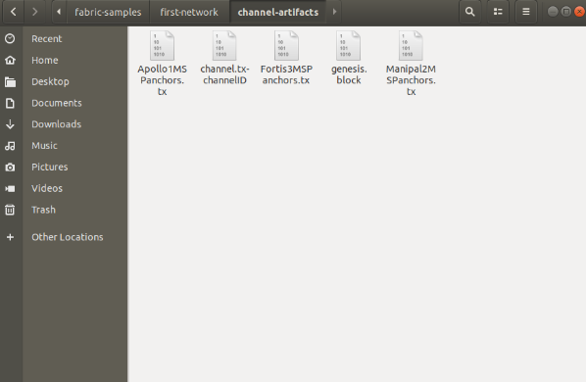

1. Update docker-compose-cli.yaml file to update the organisation names

**Copy the docker-compose-base.yaml from Hyperledgerlabs/artifacts/base to first-networks/base.**

**Copy the docker-compose-cli.yaml from Hyperledgerlabs/artifacts to first-networks.**

**\*\*\*\*\*\*\*\*\*\*\*\*\*\*\*\*\*\*\***